**المجموعة الأولى**





3- Write a program to find the inverse, the trancepose and the eigen values of the matrix

A3={{2, 0, 4},{3, 4, 5}, {4, 5, 6})



**المجموعة الثانية :**







3- Write a program to find the inverse, the trancepose and the eigen values of the matrix

A3={{6, 9, 11},{4, 4, 6}, {0, 1, 6})







3- Write a program to find the inverse, the trancepose and the eigen values of the matrix

A3={{2, 0, 4},{3, 4, 5}, {4, 5, 6})



**المجموعة الثالثة :**

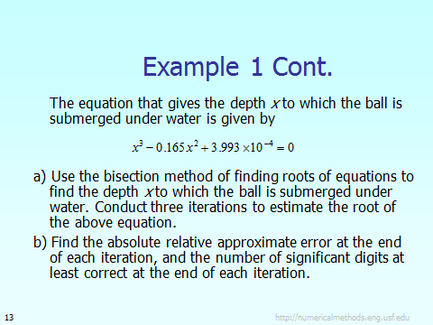



3- Write a program to find the inverse, the trancepose and the eigen values of the matrix

A3={{6, 9, 11},{4, 4, 6}, {0, 1, 6})







Write a mathematica program to fin the data in the folloing table 