**Full Paper Title (Font: Time New Roman 14 bold)**

First Author as Example: M. S. Smith*1, Second Author as Example: S. S. Gren1 and Third Author

Affiliation as Example: 1 Department of Physics, Faculty of Science, Damietta University, New Damietta City, Egypt

* Corresponding Author E-mail address: mssmith@du.edu.eg

Abstract (Font: Time New Roman 14 bold)

This file provides a template for writing papers for the DU students' conference. The full paper file could be written in compliance with these instructions. The author is asked to submit the paper in MS-Word.

An abstract not exceeding 250 words, in English, should appear on the top of the first page, after the title of the paper in chapter titled "Abstract" (without chapter number), after the names of the authors and the contact information of the corresponding author.

The authors could submit the full paper title and the abstract in English and Arabic at deadline 3/3/2017. (Font: Time New Roman 14, Spacing: single)]

The abstract has to be submitted electronically by e-mail to the following address: Dusconf1@du.edu.eg

***Key words:*** *Maximum 6 Key words.*

# Introduction (Font: Time New Roman 14 bold)

[It is expected that authors will submit carefully written and proofread material. Spelling and grammatical errors, as well as language usage problems, are not acceptable in the final submission.

The number of pages could not be exceeding 20 pages.

Papers should clearly describe the background of the subject, the authors work, including the methods used, and concluding discussion on the importance of the work. Papers are to be prepared in English or Arabic.

(Font: Time New Roman 14, Spacing: single)

The Full paper has to be submitted electronically by e-mail to the following address: [Dusconf1@du.edu.eg](mailto:Dusconf1@du.edu.eg)

# Experimental Arrangement and Procedures or/ Methodology or/ Theory (if applicable) (Font: Time New Roman 14 bold)

[Font: Time New Roman 14, Spacing: single]

Here you can give a detailed description for you experiment and procedures/ method or theory which used in your paper.

Equations (if any) should be presented on a separate line from the text with a blank space above and below. Equations should be clear and expressions used should be explained in the text. The equations should be numbered consecutively at the outer right margin, as shown in Eqs. (1) - (2) below. Here is one example.

In this case, the governing system of equations can be written as follows:

                                                               

                                                              

# Results and discussion (Font: Time New Roman 14 bold)

Here you will give the obtained results. The results and its dependent as well as manipulation will explain.

[Font: Time New Roman 14, Spacing: single.]

Figure captions and table headings should be sufficient to explain the figure or table without needing to refer to the text. Figures and tables not cited in the text should not be presented.

Tables and figures should be placed close after their first reference in the text. All figures and tables should be numbered with Arabic numerals. Table headings should be above the tables.

Here is given example for figure and table:

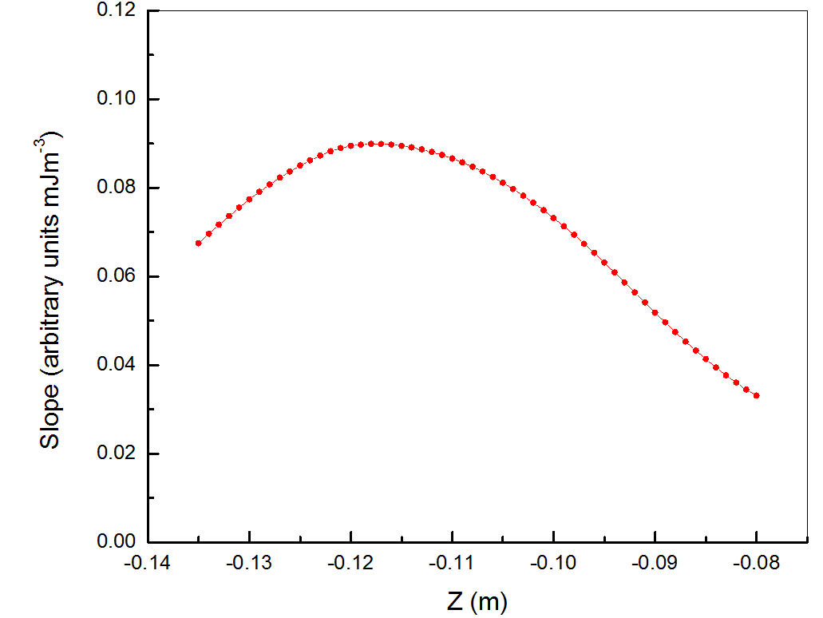

Figure 1: The mean intensity gradient values at the edges of test target element along the Z-direction with respect to hologram plane.

(Font: Time New Roman 11, Spacing: single)

Table 1: Title of the Table (Font: Time New Roman 11, Spacing: single)

|  |  |  |
| --- | --- | --- |
| **Type of nanoparticles** | **Average size (nm)** | **Variance (nm)** |
| CuO | 47 | 4.2 |
| NiO | 35 | 6.4 |
| Al2O3 | 42 | 2.1 |
| SnO2 | 27 | 3.9 |

# Conclusions (Font: Time New Roman 14 bold)

[Font: Time New Roman 14, Spacing: single]

Conclusions should state concisely the most important propositions of the paper as well as the author’s views of the practical implications of the results.

# References (Font: Time New Roman 14 bold)

[Font: Time New Roman 14), Spacing: single]

References are important to the reader; therefore, each citation must be complete and correct. There is no editorial check on references; therefore, an incomplete or wrong reference will be published unless caught by a reviewer and will detract from the authority and value of the paper. References should be readily available publications.

List only one reference per reference number. If a reference is available from two sources, each should be listed as a separate reference.

The template will number citations consecutively within brackets [1]. The sentence punctuation follows the bracket [2]. Multiple references [3], [4] are each numbered with separate brackets [4]-[6]. Refer simply to the reference number, as in [7]—do not use “Ref. [7]” or “reference [7]” except at the beginning of a sentence: “Reference [7] was the first . . .”.

At least five references could be cited in your paper.

Here are three examples for references: [1] papers, [2] book and [3] website;

1. P. J. Lezzi, Q. R. Xiao, M. Tomozawa, T. A. Blanchet, and C. R. Kurkjian, “Strength increase of silica glass fibers by surface stress relaxation: A new mechanical strengthening method,” J. Non-Cryst. Solids **379**, pp. 95–106 (2013).
2. M. Born and E. Wolf, Principles of Optics, 7th ed. (Cambridge, 1999), p. 130.
3. Chemical-book: <http://www.chemicalbook.com/ChemicalProductProperty_EN_CB4217972.htm>